

**Real estate SAAS Competitive Analysis within the EMEA**



# Competitive Analysis of Selected Real Estate SaaS Platforms within EMEA

**Client Objective:** Conduct a competitive analysis of leading real estate SaaS platforms to identify their strengths, weaknesses, opportunities, and threats (SWOT). I need this information to help us make informed decisions about our own SaaS platform.

# Name: Chiemerie Chibuzor

**Role**: Business Analyst, Market research Analyst, Data Analyst

**Stakeholder**: Product owner

**Timeline**: 2 weeks

**Month**: November 2023

# METHODOLOGY

**Data visualization**: Identiﬁcation of top 10 real estate SaaS platforms based on market share, popularity, and user reviews

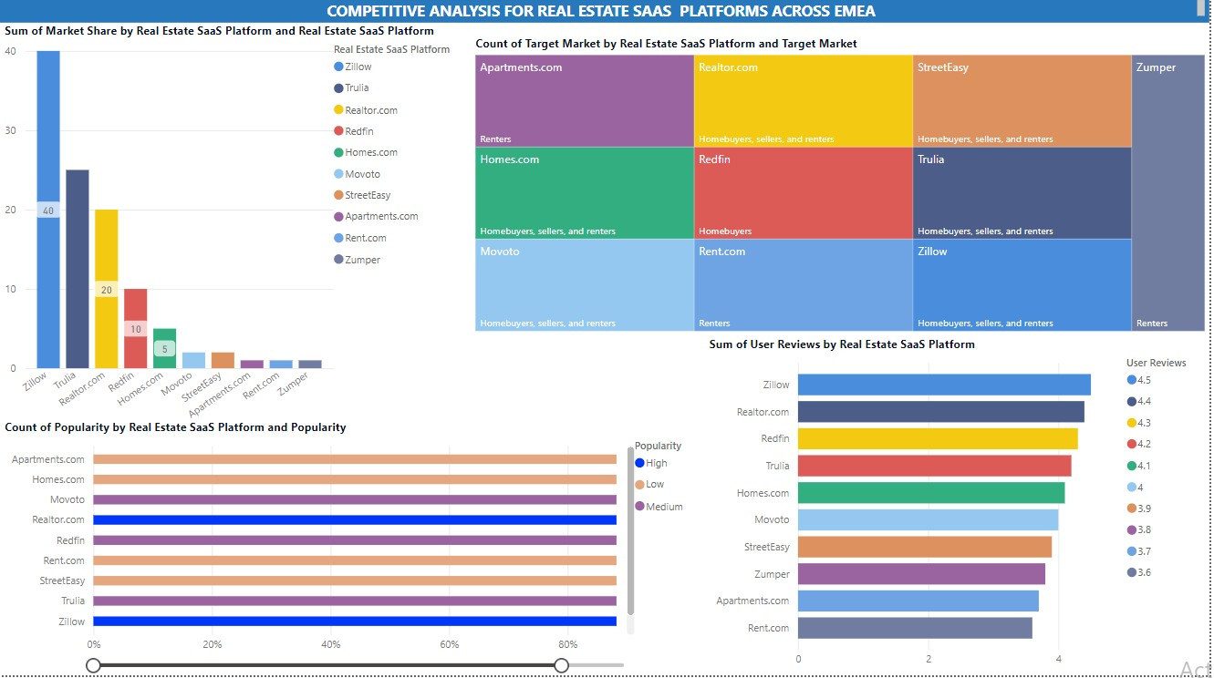

# Market Research Analysis ( Market share, Popularity, key features, Target Market)

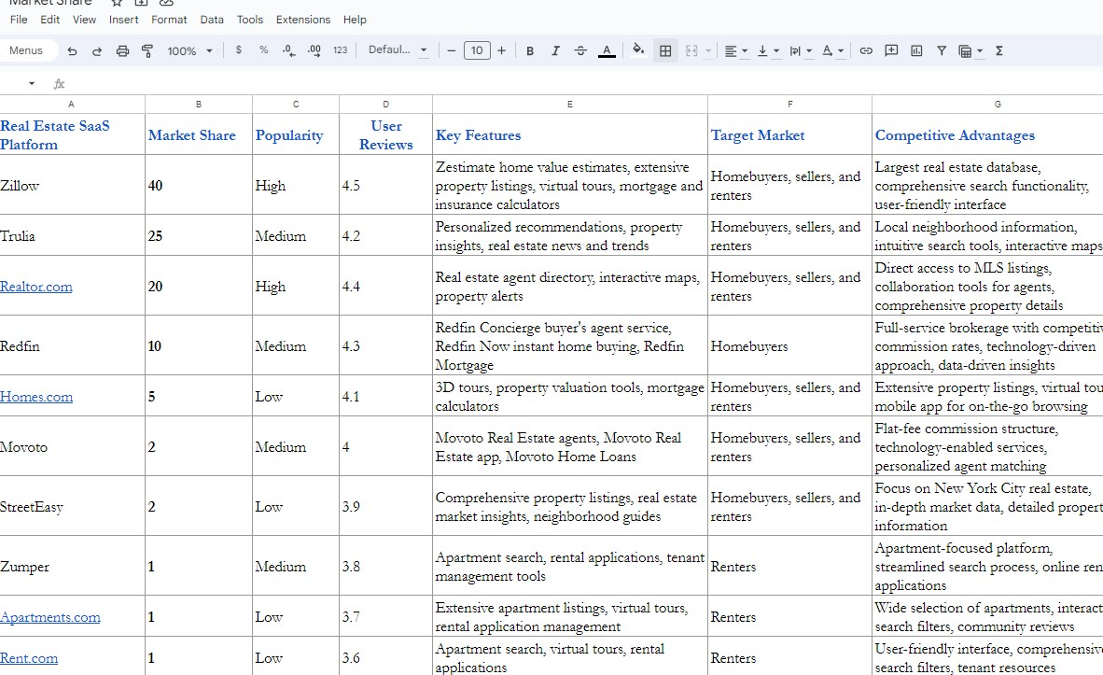

[Link to sheets](https://docs.google.com/spreadsheets/d/1RnbFGxXiWM0pKQr-rTVEu1wRhHr_kQSIlK7WJMxVhLI/edit?usp=sharing)

# SWOT matrix

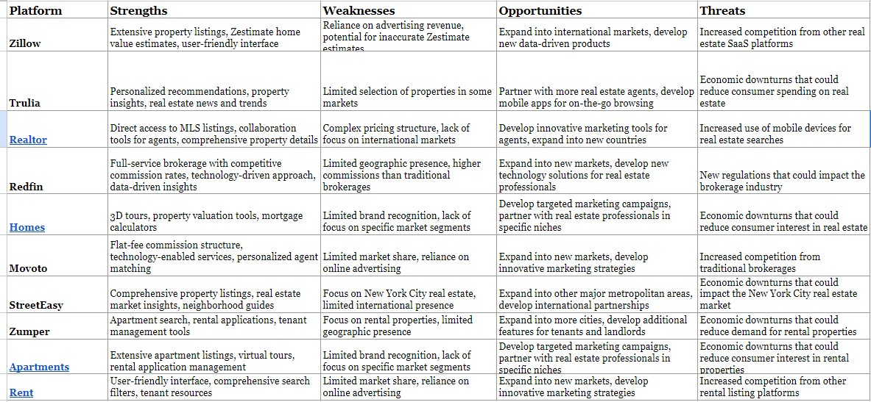

[Link to sheets](https://docs.google.com/spreadsheets/d/1RnbFGxXiWM0pKQr-rTVEu1wRhHr_kQSIlK7WJMxVhLI/edit?usp=sharing)

# Features Pricing and customer base

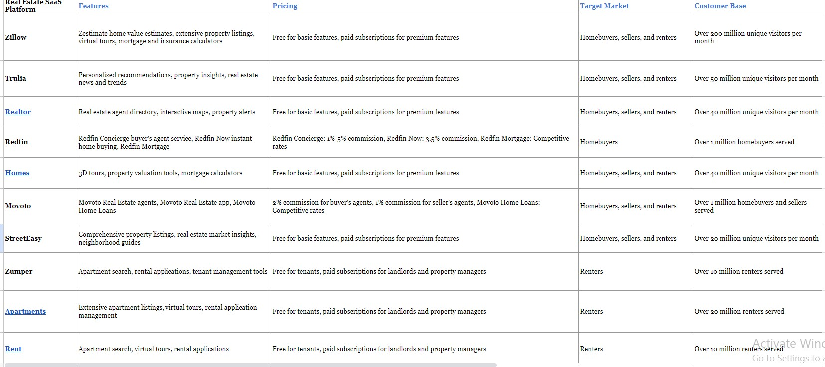

[Link to sheets](https://docs.google.com/spreadsheets/d/1dv05NkVAz3oWJpAk6VjtVZBWWc7-F7NdYHbu9pBBJKk/edit?usp=sharing)

# RECOMMENDATION

**MITIGATING LIKELY THREATS ON YOUR REAL ESTATE SAAS PLATFORM** [Read Here](https://docs.google.com/document/d/1e2Fy7gq-EdhbtbLM4D-JLczR2PL5BMdsFV8whKIiPFA/edit?usp=sharing)

# BUILDING A COMPETITIVE STRATEGY ( PRODUCT DIFFERENTIATION)

To stand out in the competitive real estate SaaS landscape, startups can consider the following strategies:

Target a Niche Market: Instead of trying to compete with established platforms for a

broad audience, startups can focus on a speciﬁc niche market, such as luxury properties,

ﬁrst-time homebuyers, or international investors. By tailoring their services and features to the needs of a particular segment, startups can establish themselves as experts in that area. Source: "How to Find a Niche Market for Your Business" by HubSpot

(<https://blog.hubspot.com/sales/niche-market>)

Hyper-focus on Customer Experience: In the real estate industry, customer satisfaction is paramount. Startups can differentiate themselves by providing exceptional customer

service, offering personalized recommendations, and addressing concerns promptly. By prioritizing customer experience, startups can build a loyal customer base and gain a competitive edge. Source: "The Importance of Customer Experience in Real Estate" by Forbes ([https://www.forbes.com/sites/steveolenski/2017/11/16/customer-experience-is-](https://www.forbes.com/sites/steveolenski/2017/11/16/customer-experience-is-everything-when-it-comes-to-real-estate-marketing/) [everything-when-it-comes-to-real-estate-marketing/](https://www.forbes.com/sites/steveolenski/2017/11/16/customer-experience-is-everything-when-it-comes-to-real-estate-marketing/))

Leverage Innovative Technologies: Technology plays a crucial role in modern real estate.

Startups can differentiate themselves by incorporating cutting-edge technologies like artiﬁcial intelligence, virtual reality, and augmented reality. These technologies can

enhance property search, virtual tours, and property management, providing a superior user experience. Source: "5 Emerging Technologies Transforming the Real Estate

Industry" by Built In ([https://www.softermii.com/blog/technologies-in-real-estate-](https://www.softermii.com/blog/technologies-in-real-estate-proptech-trends-the-changing-industry) [proptech-trends-the-changing-industry](https://www.softermii.com/blog/technologies-in-real-estate-proptech-trends-the-changing-industry))

Offer Unique Features: To stand out from the crowd, startups can develop unique features that address speciﬁc pain points or unmet needs in the real estate market. These features could include personalized property recommendations, data-driven insights, or streamlined transaction processes. Source: "How to Differentiate Your

Business in a Competitive Market" by Inc. ([https://blog.marketresearch.com/6-ways-to-](https://blog.marketresearch.com/6-ways-to-differentiate-your-business-from-the-competition) [differentiate-your-business-from-the-competition](https://blog.marketresearch.com/6-ways-to-differentiate-your-business-from-the-competition))

Emphasize Local Expertise: In the real estate business, local knowledge is highly valued. Startups can leverage their local expertise to provide personalized insights, tailored recommendations, and valuable market intelligence to clients in their speciﬁc areas. This can give them an edge over larger, more generalized platforms. Source: "The Importance of Local Expertise in Real Estate" by NAR (<https://www.nar.realtor/about-nar>)

Build Strategic Partnerships: Collaboration can be a powerful tool for differentiation.

Startups can partner with complementary businesses, such as mortgage lenders, home inspectors, or interior designers, to offer a more comprehensive suite of services and enhance the overall customer experience. Source: "The Power of Strategic Partnerships in the Real Estate Industry" by Inman ([https://www.inman.com/2023/02/21/inman-](https://www.inman.com/2023/02/21/inman-proudly-announces-2023-global-real-estate-influencers-program/)

[proudly-announces-2023-global-real-estate-inﬂuencers-program/](https://www.inman.com/2023/02/21/inman-proudly-announces-2023-global-real-estate-influencers-program/))

Embrace Data-Driven Decisions: Data is a valuable asset in the real estate market.

Startups can utilize data analytics to gain insights into customer behavior, market trends, and property valuations. These insights can inform their product development, marketing strategies, and customer targeting. Source: "The Role of Data Analytics in the Real Estate Industry" by Clever Real Estate ([https://www.getsmarter.com/blog/career-advice/the-big-](https://www.getsmarter.com/blog/career-advice/the-big-data-advantage-in-real-estate-analysis/) [data-advantage-in-real-estate-analysis/](https://www.getsmarter.com/blog/career-advice/the-big-data-advantage-in-real-estate-analysis/))

Prioritize Mobile Optimization: With the increasing prevalence of smartphones, mobile optimization is essential. Startups should ensure their platforms are user-friendly and responsive, and provide a seamless mobile experience for both buyers and sellers.

Source: "The Importance of Mobile Optimization in Real Estate" by RIS Media ([https://realestatewebsites.in/responsive-design-why-your-real-estate-website-must-be-](https://realestatewebsites.in/responsive-design-why-your-real-estate-website-must-be-mobile-friendly/) [mobile-friendly/](https://realestatewebsites.in/responsive-design-why-your-real-estate-website-must-be-mobile-friendly/))

By implementing these strategies, startups can carve out a unique position in the competitive real estate SaaS market and attract a loyal customer base.

# REAL ESTATE KEY TRENDS TO LOOK OUT FOR

Sure, here are some key trends and emerging technologies in the real estate SaaS market:

Data-driven decision-making: Real estate professionals are increasingly relying on data to make informed decisions about everything from property pricing to marketing strategies. This is leading to a demand for SaaS platforms that provide real-time market data,

analytics tools, and predictive insights.

Artiﬁcial intelligence (AI) and machine learning (ML): AI and ML are being used to

automate tasks, personalize user experiences, and make more accurate predictions. This is leading to the development of more intelligent and emcient real estate SaaS platforms.

Virtual reality (VR) and augmented reality (AR): VR and AR are being used to give

potential buyers and renters a more immersive experience of properties. This is leading to the development of virtual tours, virtual staging, and AR apps that allow users to visualize furniture and décor in their homes.

Fractional ownership: Fractional ownership platforms are making it possible for more people to invest in real estate. This is leading to a demand for SaaS platforms that

support fractional ownership transactions and management.

PropTech ecosystems: PropTech ecosystems are emerging, with different SaaS platforms integrating to provide a more seamless user experience. This is leading to the

development of open APIs and data-sharing standards.

Emerging Technologies

Blockchain: Blockchain is being used to create secure and transparent platforms for real estate transactions, title management, and fractional ownership.

Internet of Things (IoT): IoT devices are being used to collect data about properties, such as energy consumption and security status. This data can then be used to improve

property management and tenant experiences.

Voice assistants: Voice assistants are being used to control smart homes and provide information about properties. This is leading to the development of voice-enabled real

estate SaaS platforms.

3D printing: 3D printing is being used to create custom homes and furniture. This is leading to the development of 3D printing-enabled real estate SaaS platforms.

These trends and technologies are shaping the future of the real estate SaaS market. Real estate professionals who can adopt these technologies will be well-positioned for success in the years to come.

# Deliverables:

1. A comprehensive report summarizing the ﬁndings of the competitive analysis.
2. A SWOT matrix for each of the top 10 real estate SaaS platforms.
3. Recommendations for how the startup can differentiate itself from its competitors.
4. Key Trends in the Industry
5. Additional Notes: Threats and Mitigations

I hope you grabbed some insights! thank you for reading